24ADI204 - Data Science & Visualization
Team Number: 18
Week-03 Report
Data Cleaning & Outlier Detection
Project: House Price Analysis and Dashboard

1. Activity / Milestone
This week focused on cleaning the housing dataset and detecting outliers. The objective was to remove duplicate records, handle missing values and identify abnormal values using boxplots and the IQR method, so that the data is reliable for analysis.

2. Dataset Description
The raw dataset contains 4,675 house sale records with 18 attributes, including 1,219 missing values and 75 duplicate rows found in Week 2. After cleaning, the final dataset was saved as housing_cleaned.csv for the next stage.

3. Cleaning Summary
Duplicates were removed, numerical gaps were filled with the median and categorical gaps with the mode. Outliers were then detected for all 13 numerical columns.
GITHUB REPOSITORY LINK:
https://github.com/wahith628-cmyk/Housing-
COLAB NOTEBOOK LINK:
https://colab.research.google.com/drive/1KAtVlM3go3ssdov3AtYui318LcVl_YK9
DATASET LINK (KAGGLE):
https://www.kaggle.com/datasets/ananthaselvane/housing-dataset
Metric | Before Cleaning | After Cleaning
Total Rows | 4,675 | 4,600
Total Columns | 18 | 18
Missing Values | 1,219 | 0
Duplicate Rows | 75 | 0

4. Code Implementation
A copy of the raw data (df_clean) was created so the original stays safe. Duplicates were dropped with drop_duplicates(). Missing numerical values were filled with the median because the data is skewed, and missing categorical values were filled with the mode. Boxplots and the 1.5 x IQR rule were then used to detect outliers.
CODE SCREENSHOT (Before cleaning):
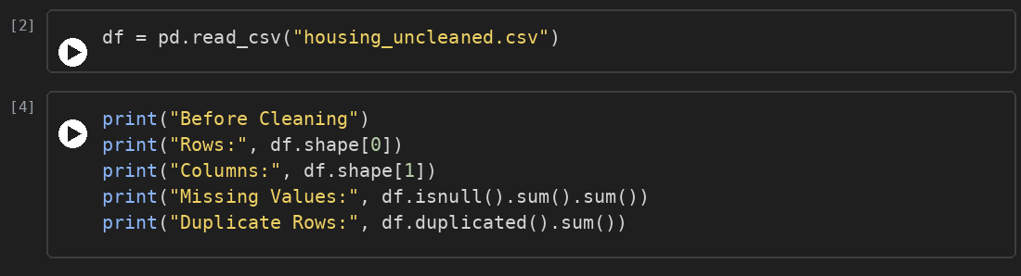
OUTPUT:
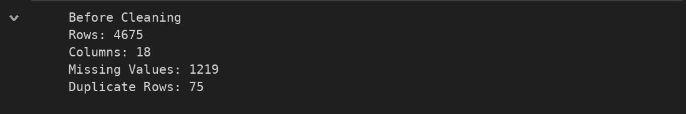
CODE SCREENSHOT (Cleaning):
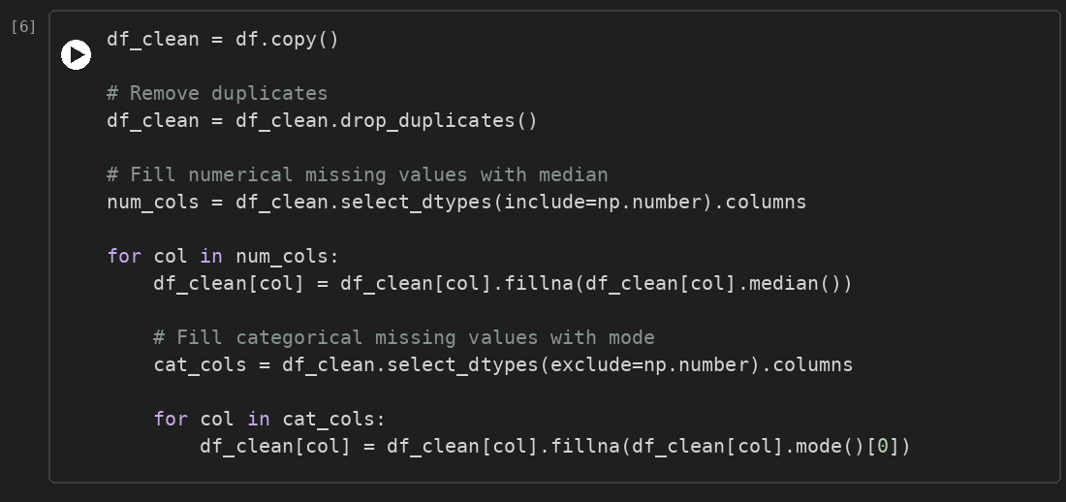
CODE SCREENSHOT (After cleaning):
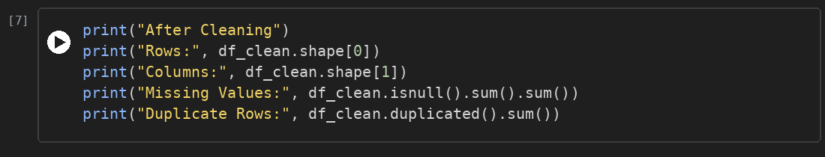
OUTPUT:
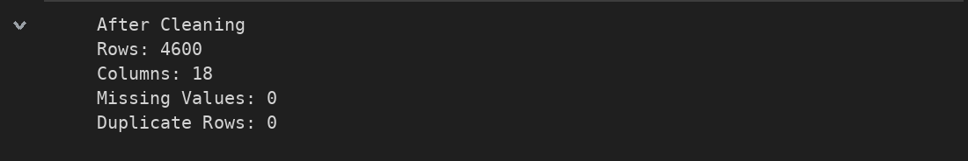
CODE SCREENSHOT (Boxplots):
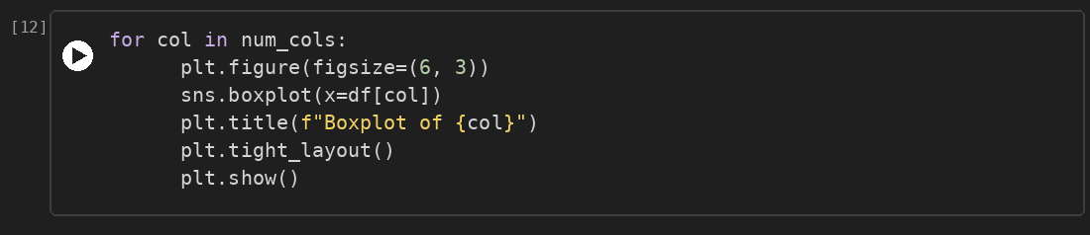
OUTPUT (price, sqft_living and sqft_lot):
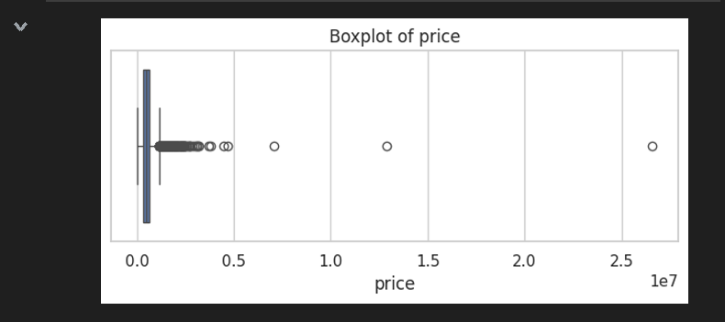
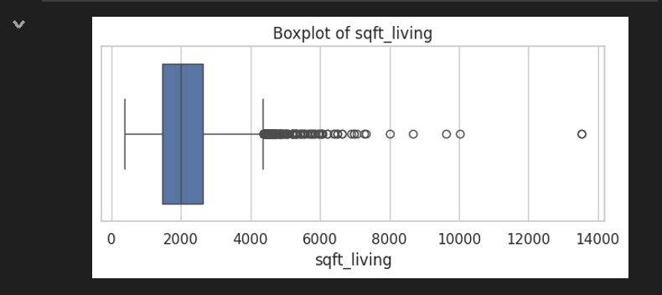
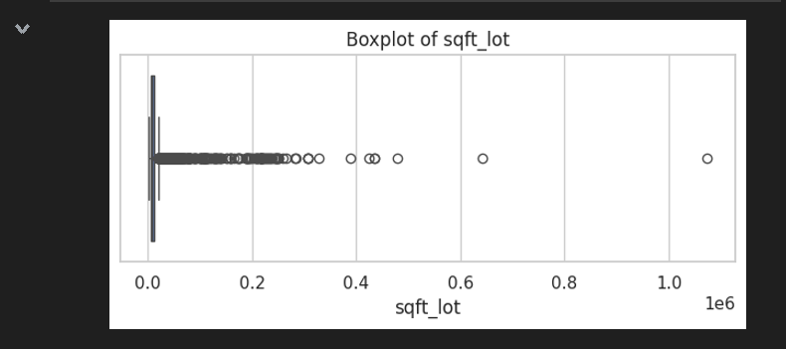
CODE SCREENSHOT (IQR outlier detection):
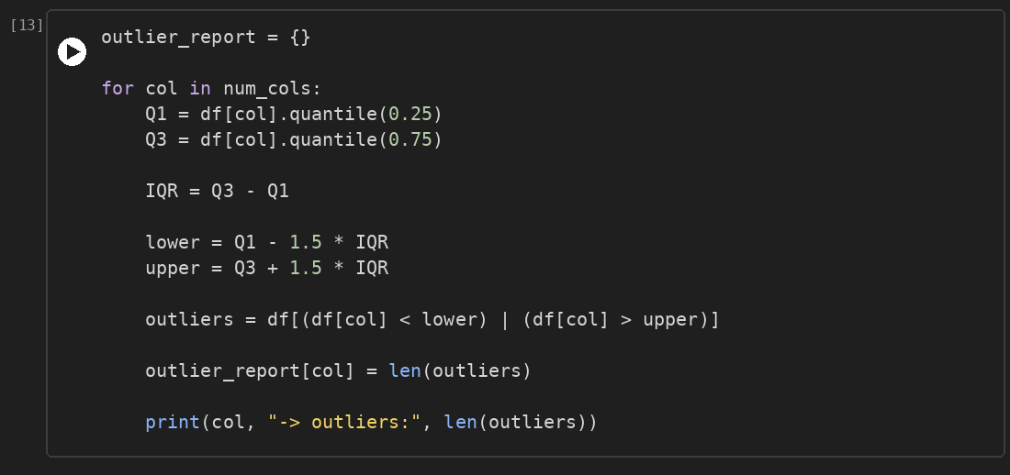
OUTPUT:
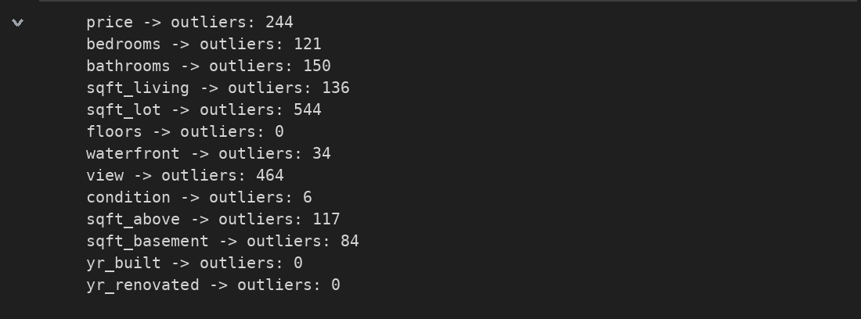

5. Screenshots & Error Handling
The data quality problems found in Week 2 were handled as shown below. After cleaning, the dataset has no missing values and no duplicate rows.
Problems Handled:
Problem | Technique | Result
75 duplicate rows | drop_duplicates() | 0 duplicates, 4,600 rows left
Missing numerical values | Median imputation | 0 missing values
Missing categorical values (street, city, statezip) | Mode imputation | 0 missing values
Outliers in numerical columns | Boxplot and IQR method | Identified; kept for now

Key Insights:
- Only 75 rows (1.6%) were removed, so almost all the data is retained.
- The IQR method flagged the most outliers in sqft_lot (544), view (464) and price (244), followed by bathrooms (150), sqft_living (136) and bedrooms (121). floors, yr_built and yr_renovated have none.
- view, waterfront and condition use small scales, so their flagged values are not true outliers.
- Outliers were identified but not removed, because large houses and expensive houses are real cases. Invalid values such as price = 0 will be filtered at the analysis stage.

6. Team Contributions
Team Member | Working | Outcome
Inban S | Data Engineer | Interpreted the outlier results and compiled the Week 3 report
Abdul Wahith M | Data Analyst | Applied the IQR method and prepared the outlier summary
Dharshan P | Visualization Expert | Created the boxplots for all numerical features
Anantha Selvan E | Story Teller | Removed duplicates, handled missing values and saved the cleaned dataset

